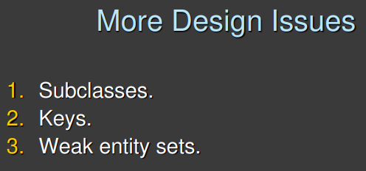

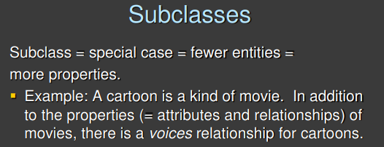
Subclasses define more specific properties. The class animal is very generic and a subclass of animals is dogs.

It happens that in the dataset mentioned, data is more specific than other data.

Is very important to be able for example to identify that a movie is a cartoon. You might need the subset because you have a specific relation (like voice relationship, useless with movies and matters only in cartoons).

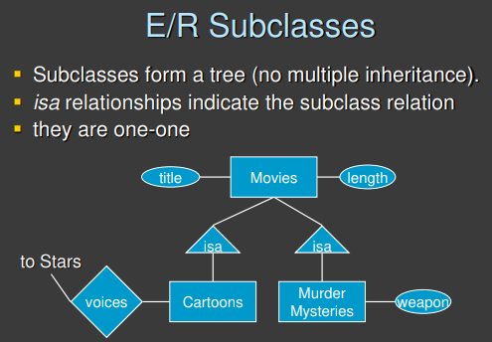
We use this notation for subsets isa [use triangle]. We can build hierarchies of entity sets. Cartoons and murder mysteries are subset of the entities set movies.

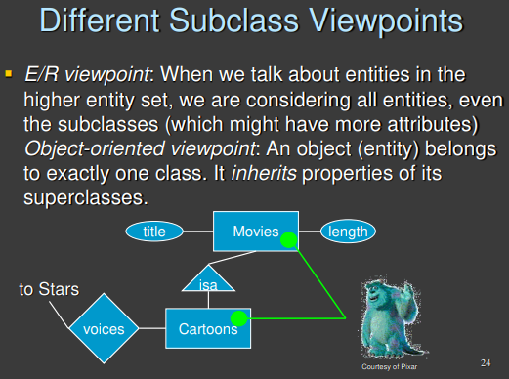
In SQL the objects that are cartoons are also movies. If you query all the movies you get also the cartoons, while if you query only the cartoons you will get the cartoons only.

You do not need the key for the cartoon set because if you already have the key for the movies you also have the key for the cartoons.

If you have individuals with the social security number as the key you will use the ssn as key also of students, doctors, … the subclass inherit the key from the parent class (aka superclass).

We can add additional attributes to the subclasses that are specific to a subclass.

Every attribute of the subclass (like date of the movies) are inherited to the subclass. I do not need to repeat that the cartoons have a date. We only need to add the additional attributes (if we want).

How to define a subclass (there might be or not one or more intersections between subclasses, a subclass can be the entire set, …)

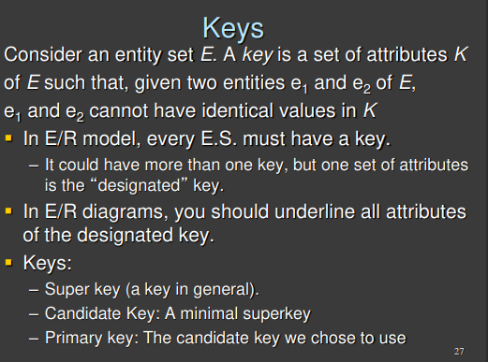

Every entity in the database must be identified in some way or another. We need to be careful in how we choose the key

There can not be two entities in the entity set with the same key.

- superkey/key: there can not be two entities with the same key (like there can not be two entities with the same ssn and surname), but this is not a minimal key, there is an attribute that even if you remove it you will still have a key
- candidate/minimal key: a minimal superkey. If you remove an attribute (like from two you go to one) then it is not able to discriminate between the entities. There might be different combinations
- primary key: the minimal key you decide to use to identify the entity

You need to identity the candidate key, try to find the minimal attributes

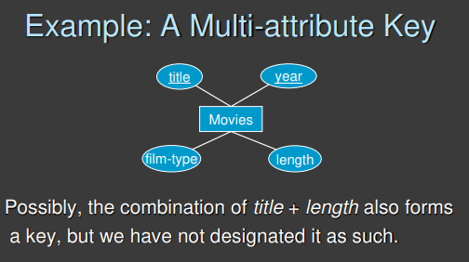
One minimal key is title + year. But a possible minimal key is the combination of title+length. You might have different options, choose the most useful/representative key.

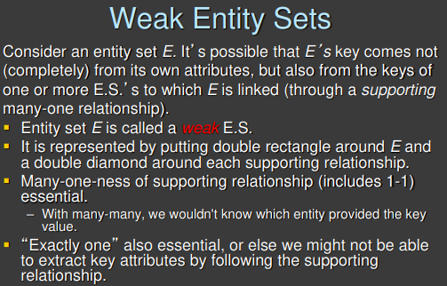

Weak entity set. When we want to identify entities the primary key has to be constructed using attributes of the entity set.

There are cases in which an entity to be completely identifiable in your dataset requires some data about the entity together with some data coming from other entities. It is not possible to identify the entity by using only attributes that are specific to the entity.

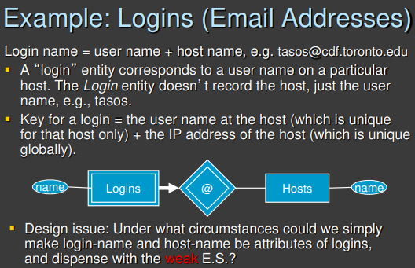
Example: storage accounts.

An email account is uniquely identified by the combination of two elements: the name (titodrugman14) and the server (gmail.com). Is the username and the server on which I have the account.

But the server name is not specific to my account.

We say that it is weak by using the relationship [double rhombus] to exists it needs an entity outside.

The key that identifies an account is the combination of two things (the username) and the key of another entity.

Use ⟹ because it needs to be connected to exactly one server.

The key is the combination of the attributes I highlighted + all the key of all the entity set connected to it.

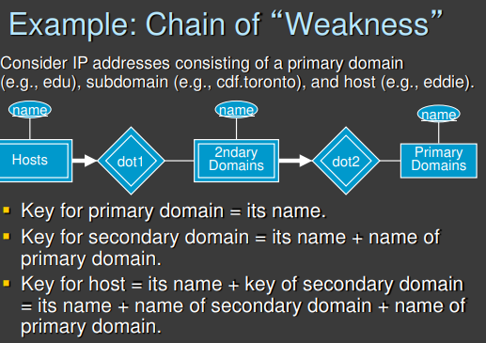

This is discouraged. Three levels of domains. titodrugman@studenti.unimib.com

use weak entity set only if it is really needed.

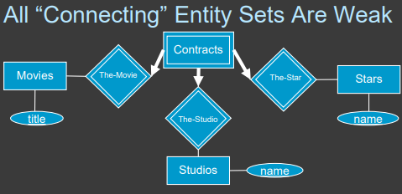
We can convert a ternary to a binary relationship.

Now if we consider a contract as a weak entity set now we can see that a contract is uniquely identity by three elements
- Movie
- Studios
- Stars

But now with the weak entity set the key of a contract is really the combination of three things.
Now a contract requires the existence of these three elements. If I remove one element the contract does not have a meaning.

With a normal entity set and a normal relationship then the contract is still connected to exactly one movie, exactly one actor and exactly one studio. But if I remove the actor from the system then the contract has its own identity. You are fine even without an actor (but it does not really make sense, so is better use a weak entity set)..

